LAB 03
Tasks:

  - Place a hyperlink in your Institute name and link that text to your Institute official page.

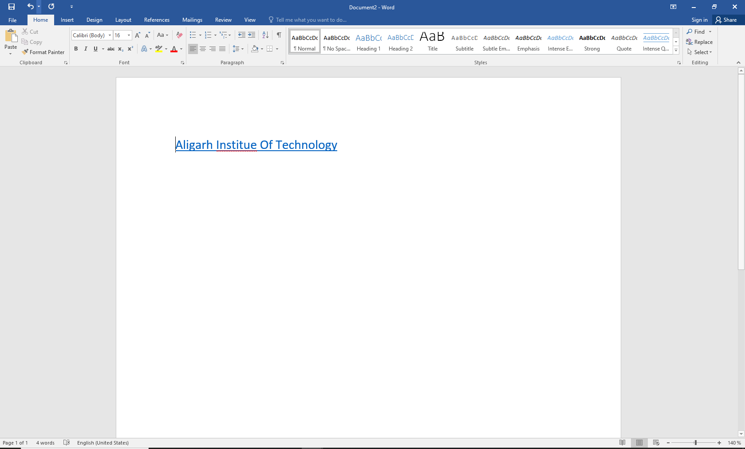

  - Create an unordered list of your courses name.

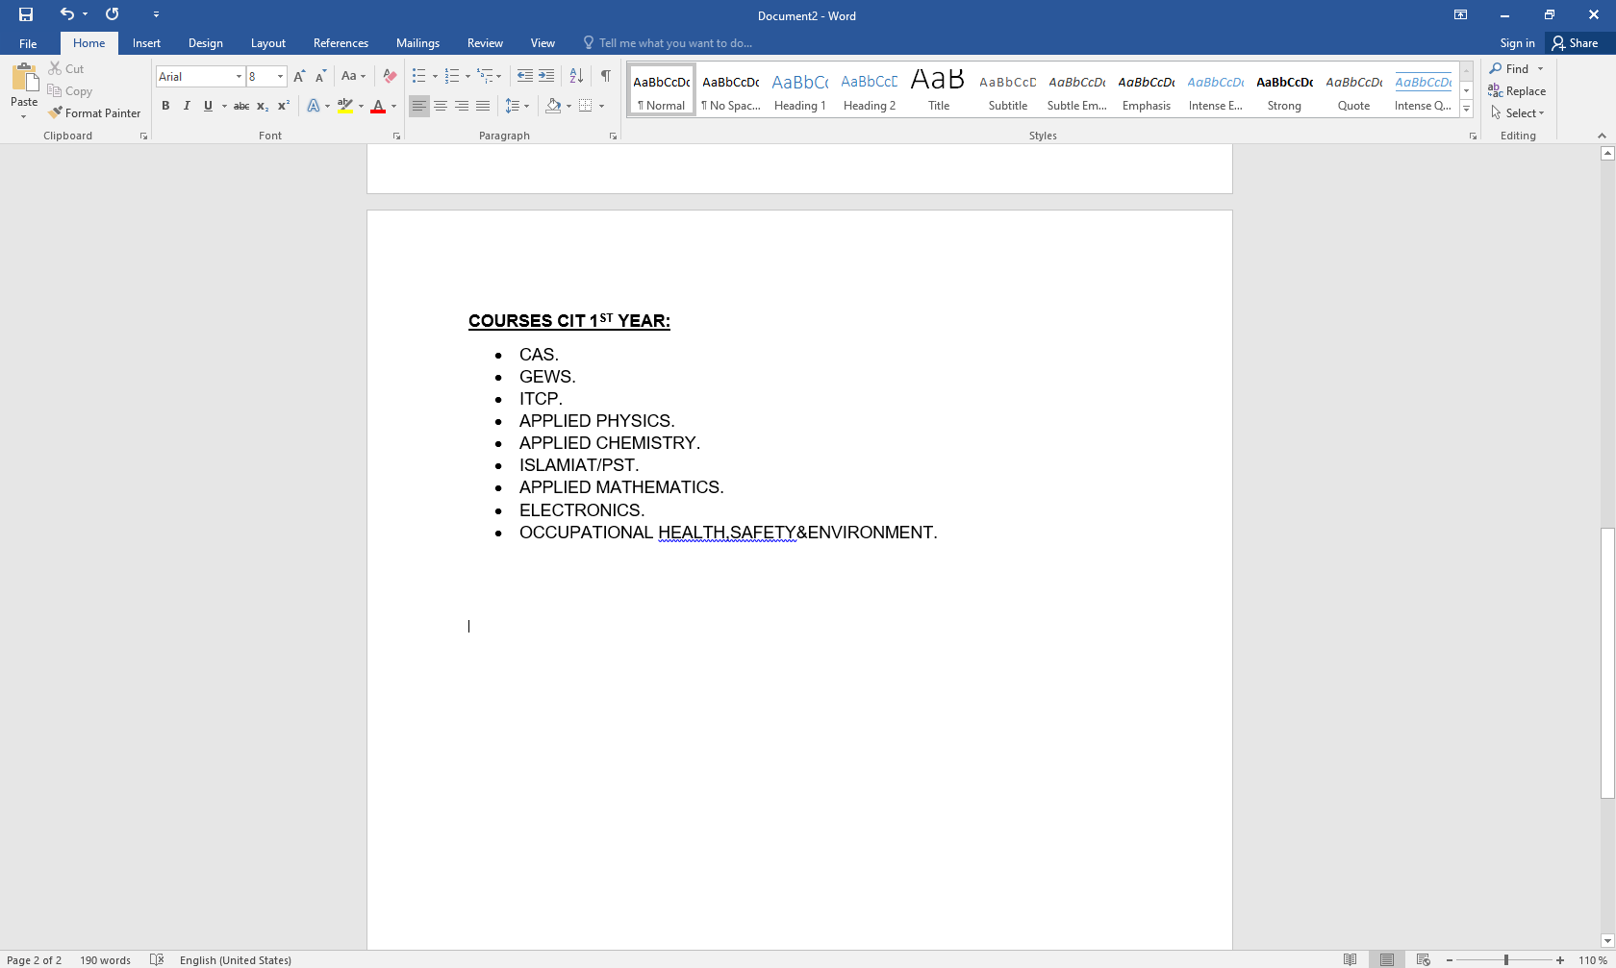

  - Write an application to your principal for full fee concession on word.

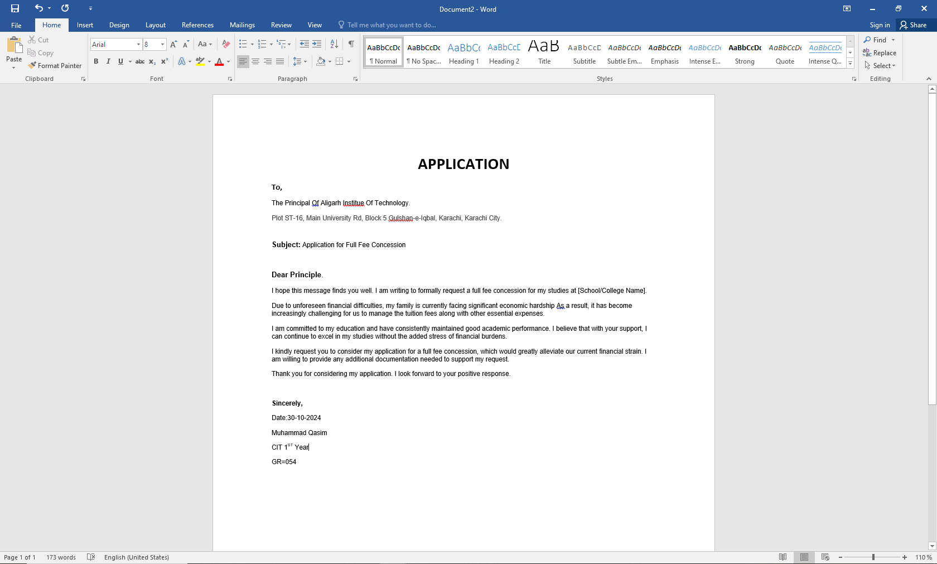

  - Change the page orientation to Portrait.

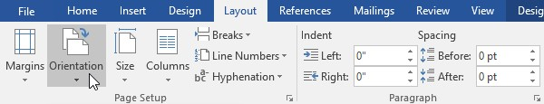

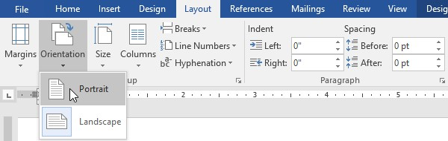

  - Change the page size to Legal. If Legal size is not available, you can choose another size such as A5.

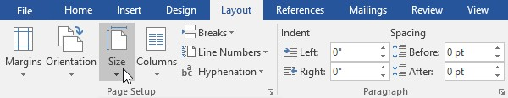

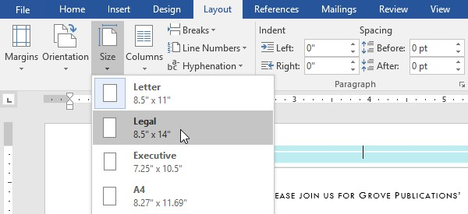

  - Change the margins to the Narrow setting.



